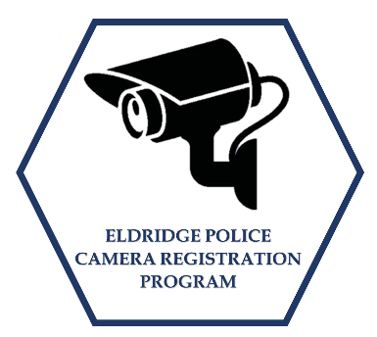

Security Camera Registration

If you have a residential or business security camera, the Eldridge Police Department would like to partner with you. The Eldridge Police Department is looking to establish a map of exterior facing camera locations throughout the City.
Security cameras can be a powerful tool in helping deter crime as well as identifying offenders when crimes are captured on video. Participation in this program will help strengthen our investigative abilities and give us and easier way to communicate more effectively with potential witnesses.
By signing up, you WILL NOT be giving the Police Department direct or remote access to your cameras. You are simply letting us know the cameras exist so that we can reach out to you if a crime happens in your neighborhood. The Eldridge Police Department will keep the information provided by the registrant confidential and will only be viewed by the Eldridge Police Department during criminal investigations.
We thank you for your part in helping to protect the Eldridge Community!

Please answer the following questions to register your security camera with the Eldridge Police Department.
Camera is at: Business Residence
Address camera is located at:____________________________________
Contact Person:______________________________________________
Phone Number:______________________________________________
Device Type:________________________________________________
Number of Cameras:__________________________________________
Location of Cameras:
Front Yard Backyard Doorbell Driveway Alley Parking Lot Other: ___________________________________________________

Does your system record and save video?_________________________
Does your system record audio?________________________________

